Instruction
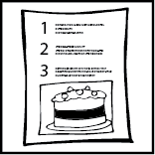

Name
Date

Write a title  Recipe for ...  How to ... | Title
Show a picture of the finished product.
Tell what the instructions are about. |  | This step-by-step instruction shows ...
Write a list of the things needed - with bullet points. | You will need
List the steps to be taken in correct order.  Use ’bossy’ verbs (imperative verbs): fold, wash, put, chop, spread, place, measure, sort, don’t forget, close, stir … | What to do  - First ...  - The next step is to …  - After that …  - When you have done this …  - Remember to …  - Finally, …

